Dear Ricky,

As requested, we would like to set out below our comments on relevant Vietnam tax implications in relation to the contemplated payment model of XXX for your information and consideration.

- Background

- XXX (“XXX” or “the Company”) is a US-based entity and a part of XXX Group, which operates a platform which allows merchants to collect payments for goods/services from their customer’s digital wallets or mobile phones. End users enter into commercial transactions with merchants (typically very large online merchants based in the US and other locations outside of Vietnam, such as Apple, Spotify, Microsoft, etc.) to pay for products using either their mobile phone number or digital wallet, with XXX Group facilitating the transactions in the background.

- The current contemplated payment model of XXX is illustrated as follows:

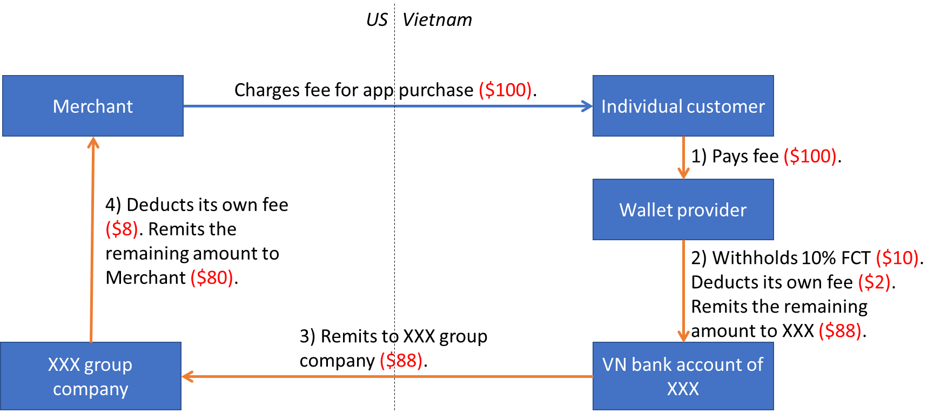

- With an aim to understand the Vietnam tax implications and any other local considerations, XXX has requested KPMG to provide high level Vietnam direct and indirect tax advice in relation to the above transaction flows to be undertaken by XXX.

- Executive summary

- Please see below the key Vietnam tax implications of the contemplated payment model:

- In transaction (3) where XXX remits money from its bank account in Vietnam to the XXX group company offshore, given that the wallet provider will have already withheld, declared and paid Foreign Contractor Tax (“FCT”) on the fee earned by the Merchant in the previous transaction 2, no further FCT should be imposed on the fee earned by the Merchant in this step.

For transaction (4), given such transaction is conducted outside Vietnam, and XXX group company earns fee from the Merchant rather than from a Vietnam entity/individual, technically there should be no FCT implication. However, further official confirmation with the Vietnam tax authorities (“VTA”) on this issue is recommended.

- In transaction (2), the wallet provider should calculate FCT on the tax base being the full fee charged by the Merchant to the customer (i.e., not deducting its own fee from the tax base).

- In case the fee charged by the Merchant is for purchase of an app (such as the case of Microsoft, Apple, etc.) which meets the definition of computer software under Vietnam laws, FCT rates of 10% Corporate Income Tax (“CIT”) and nil Value Added Tax (“VAT”) shall apply.

In case the fee charged by the Merchant is for use of a media platform (such as the case of Spotify, Netflix, etc.), FCT rates for normal services of 5% CIT and 5% VAT are commonly applied in practice. Nevertheless, there is still a risk that an aggressive VTA may deem such fee as royalties and impose higher FCT rates. Further official confirmation with the VTA on this issue is recommended.

- There is a low risk that the Vietnam bank account maintained by XXX in Vietnam for the purpose of collecting and remitting money out of Vietnam in the course of its business activities may be deemed as constituting a permanent establishment (“PE”) of XXX in Vietnam. Further analysis of this matter is required.

- Please note that, given the lack of review of the detailed contractual agreements, and given mainstream tax regulations do not provide guidance for the specific contemplated payment model as illustrated above, we provided our comments based on our interpretation of current Vietnam tax regulations and unofficial discussions with our General Department of Taxation (“GDT”) contacts. Official confirmation with the VTA on the tax treatment for the contemplated payment model is recommended before implementation.

- Detailed comments on Vietnam tax implications of the contemplated payment model

- Under the current tax administration regulations of Vietnam (i.e., Circular 80), for digital-based B2C business activities conducted by foreign suppliers in Vietnam without creating a PE, such as the Merchant in this case, the following compliance requirements are provided:

- The Merchant may choose to register to self-declare and pay FCT in Vietnam directly through an e-portal of the GDT. Under this option, the Merchant shall declare and pay the applicable taxes on income arising from Vietnam on a quarterly basis; or

- If the Merchant chooses not to register to self-declare and pay tax in Vietnam directly, Vietnam commercial banks and Vietnam payment intermediaries (via whom customers make payments to the Merchant) must declare, withhold and remit FCT to the local VTA on behalf of the Merchant on a monthly basis.

- However, mainstream tax regulations do not provide guidance for the specific contemplated payment model as illustrated above, in which there are many layers of payment processing by the Vietnam wallet provider, XXX and XXX group company. In addition, currently we do not have the opportunity to review the detailed contractual agreements between the parties in such model.

- In this regard, based on our interpretation of current Vietnam tax regulations and unofficial discussions with our GDT contacts, we would like to set out below the key Vietnam tax implications in principle of the contemplated payment model for your consideration:

- Regarding FCT implications for transactions (3) and (4) of the contemplated payment model:

- For transaction (3), we understand that the wallet provider (i.e., the Vietnam payment intermediary) will have already withheld, declared and paid FCT on the fee earned by the Merchant before remitting to XXX’s bank account in Vietnam in the previous transaction 2, which is in line with the regulations quoted above. Accordingly, no further FCT shall be imposed on the fee earned by the Merchant in transaction (3), and the Vietnam commercial bank is not required to withhold, declare and pay FCT in this step. Please note that, sufficient evidence on FCT declaration and payment should be provided to the Vietnam commercial bank to prove that the wallet provider has properly withheld, declared and paid FCT on the fee earned by the Merchant.

- For transaction (4), given such transaction is conducted outside Vietnam and XXX group company earns fee from the Merchant rather than from a Vietnam entity/individual, technically there should be no FCT implication. However, we do not exclude the risk that an aggressive VTA may try to interpret that XXX’s fee ultimately arose from Vietnam (i.e., the fee collected by the Merchant from the Vietnam customer includes XXX’s fee), and collect FCT accordingly. This is so far unprecedented, but further official confirmation with the VTA on this issue is recommended.

- Regarding the tax base on which the wallet provider calculates FCT in transaction (2) of the contemplated payment model:

- According to FCT regulations of Vietnam (i.e., Circular 103), in case a foreign supplier provides goods/services to a Vietnam entity under an agreement, and (i) subcontracts a part of the work under such agreement to a Vietnam sub-contractor and (ii) purchases goods/services in Vietnam for purposes other than to perform the work under such agreement, then only portion (i) is deducted from the tax base to calculate FCT of the foreign supplier (provided supporting documents are properly maintained). Portion (ii) will not be deducted from the tax base as it is not for the purpose of performing the work under the agreement.

- In light of the above regulations, it can be interpreted that given the fee deducted by the wallet provider does not serve any purpose in the Merchant’s service provided to the customer, and is only for the Merchant to collect money from the customer, such fee shall not be deducted from the tax base. In other words, the wallet provider should calculate FCT on the full fee charged by the Merchant to the customer. Please see the chart in Appendix 2 for illustration purpose.

- Regarding the FCT rates applicable to the fee earned by the Merchant:

- FCT in Vietnam comprises a CIT portion and a VAT portion. For normal service provision, the FCT rates of 5% CIT and 5% VAT shall apply. For royalty fees on intellectual property license, the following FCT rates shall apply:

- 10% CIT and VAT exempt for royalties which include transferring the ownership of intellectual properties.

- 10% CIT and 5% VAT for royalties which include transferring the right to use intellectual properties.

- In addition, according to current Vietnam VAT regulations, computer software (including software products and software services) is not subject to VAT. The definition of computer software is provided in Decree 71 as detailed in Appendix 3.

- Accordingly, in case the fee charged by the Merchant is for purchase of an app (such as the case of Microsoft, Apple, etc.) which meets the definition of Decree 71, such fee shall be classified as royalties for transferring the right to use software and subject to FCT rates of 10% CIT and nil VAT.

In case the fee charged by the Merchant is for use of a media platform (such as the case of Spotify, Netflix, etc.), mainstream tax regulations and private guidance are not clear on FCT rates in such case. However, we have observed that in similar cases in practice, the FCT rates for normal services of 5% CIT and 5% VAT are commonly applied. Nevertheless, there is still a risk that an aggressive VTA may deem such fee as royalties for the right to use intellectual properties and impose higher FCT rates. Hence, further official confirmation with the VTA on this issue is recommended.

- Regarding PE exposure for XXX in Vietnam:

- PE definition under the Vietnam domestic law is very broadly defined and may include a place or a person through which a foreign enterprise carries out some or all of its production and trading activities in Vietnam. Accordingly, there is a low risk that the Vietnam bank account maintained by XXX in Vietnam for the purpose of collecting and remitting money out of Vietnam during the course of its business activities may be deemed as constituting a PE of XXX in Vietnam.

- Please note that given the limited scope of work and the lack of documentation review, we did not perform further PE analysis in the context of this memo. In case a formal analysis of PE exposure and associated tax implications are required, we are happy to support under a separate fee arrangement.

- Interpretation of future change in laws

We have been requested to advise on the Vietnam tax and regulatory consequences associated with the above arrangements only. Our advice therefore focuses on current laws and regulations within the Socialist Republic of Vietnam and will not consider issues belonging to other tax jurisdictions.

The advice has been prepared based on the documents and information supplied by you and the current laws and regulations, which are issued by the competent authorities of Vietnam, as at the date of the advice. Where regulations are quoted in English in this advice, the quotation may be from a KPMG unofficial translation of the source document and not an official translation. You will appreciate that the tax law is frequently being changed, both prospectively and retrospectively. A number of key tax reform measures have been implemented, a number of other key reforms have been deferred and the status of some key reforms remains unclear at this stage.

Unless special arrangements are made, our advice provided will not be updated to take account of subsequent changes to the tax legislation, case law, rulings and determinations issued by the Vietnam tax governing bodies or other practices of taxation authorities. It is your responsibility to seek further advice or updates, if you are to rely on our advice at a later date.

We are, of course, unable to give any guarantee that our interpretation will ultimately be sustained in the event of challenge by the Vietnam tax authorities.

Our above advice is for the Company's use only and may not be distributed to, or relied on, by any other party.

We trust the above is helpful for your purposes. Please do not hesitate to contact us know should you need further clarification.

Yours sincerely,

Nguyen Thanh Tam
Managing Director, Tax

APPENDIX 1 – APPLICABLE REGULATIONS

- Circular 80/2021/TT-BTC dated 29 September 2021 of the Ministry of Finance providing guidance on tax administration law;

- Circular 103/2014/TT-BTC dated 06 August 2014 of the Ministry of Finance providing guidance on FCT;

- Decree 71/2007/ND-CP dated 03 May 2007 of the Government providing guidance on IT law; and

- Other relevant regulations on the issues discussed herein.

APPENDIX 2 – TAX CALCULATION ILLUSTRATION

The following chart is for illustration purposes only, assuming the Merchant’s fee for app purchase is $100, the wallet provider’s fee is $2, XXX’s fee is $8, and the FCT rate is 10% (i.e., 10% CIT and nil VAT).

APPENDIX 3 – DEFINITION OF SOFTWARE PRODUCTS AND SOFTWARE SERVICES

According to Decree 71, software products include:

- System software;
- Application software;
- Utility software;
- Tools software; and
- Other software.

According to Decree 71, software services include:

- Administration, warranty and maintenance services for software and information systems;
- Software consulting, assessment and quality appraisal services;
- Software project consulting and building services;
- Software pricing consulting services;
- Software technology transfer services;
- System integration services;
- Safety and security assurance services for software products and information systems;
- Software product distribution and supply services; and
- Other software services.

Circular 80/2021/TT-BTC dated 29 September 2021 of the Ministry of Finance providing guidance on tax administration law (“Circular 80”)
Circular 103/2014/TT-BTC dated 06 August 2014 of the Ministry of Finance providing guidance on FCT (“Circular 103”)
Decree 71/2007/ND-CP dated 03 May 2007 of the Government providing guidance on IT law (“Decree 71”)

